Home Assistant Virtual Machine Usage

Install virtual machine software
- Download: https://www.virtualbox.org/wiki/Downloads
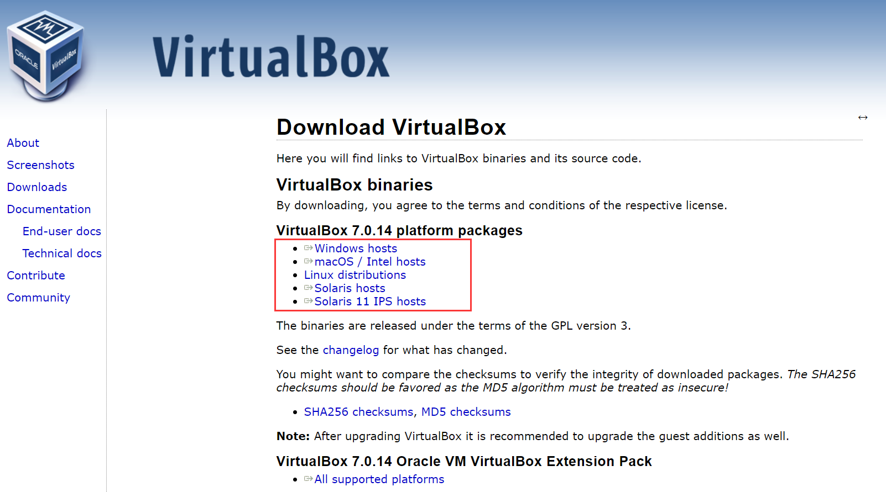
Install it according to installation guide.
In order to run VirtualBox on your machine, you need:

Reasonably powerful x86 hardware. Any recent Intel or AMD processor should do.
Memory. Depending on what guest operating systems you want to run, you will need at least 512 MB of RAM (but probably more, and the more the better). Basically, you will need whatever your host operating system needs to run comfortably, plus the amount that the guest operating system needs. So, if you want to run Windows 8.1 on Windows 7, you probably won't enjoy the experience much with less than 2 GB of RAM. Check the minimum RAM requirements of the guest operating system, they often will refuse to install if it is given less. Sometimes it malfunctions instead. So you'll need that for the guest alone, plus the memory your operating system normally needs.
Hard disk space. While VirtualBox itself is very lean (a typical installation will only need about 30 MB of hard disk space), the virtual machines will require fairly huge files on disk to represent their own hard disk storage. So, to install Windows 8, for example, you will need a file that will easily grow to several 10 GB in size.
A supported host operating system. Presently, we support Windows, many Linux distributions, Mac OS X, Solaris and OpenSolaris. Check the user manual of the VirtualBox version you are using which versions are supported. For the latest VirtualBox version, see manual.
https://www.virtualbox.org/manual/ch01.html#hostossupport/
For up-to-date details, especially on current operating system support and software requirements, please take a look at the current User Manual
User Manual : https://www.virtualbox.org/wiki/Downloads#manual
Online: https://www.virtualbox.org/manual/UserManual.html

Unzip the VM OVA zipped file
Please unzip the zipped files in one folder, and then you will get a “homeassistant.ova” file.
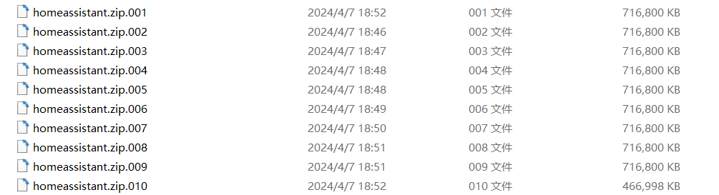

Import appliance
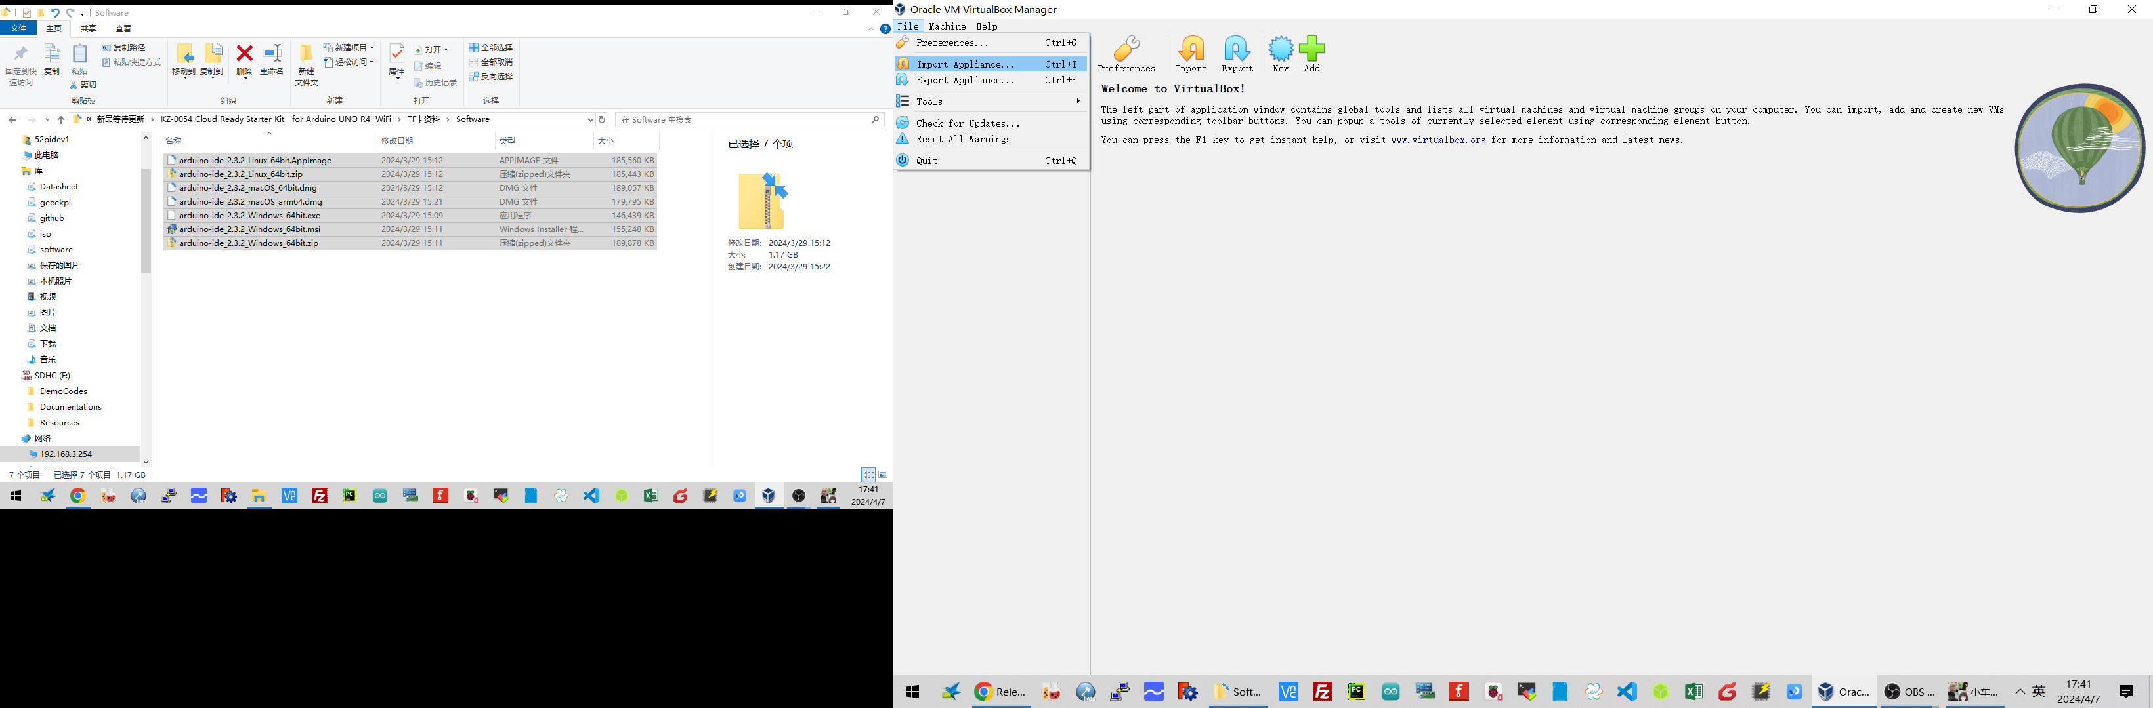
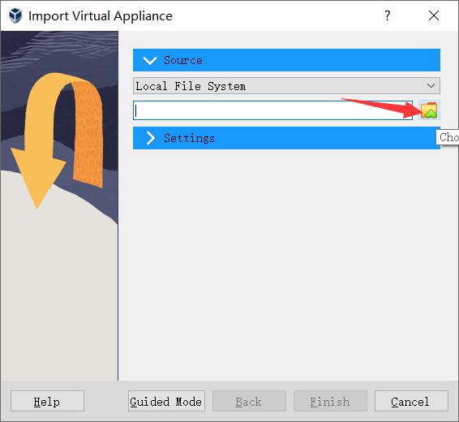
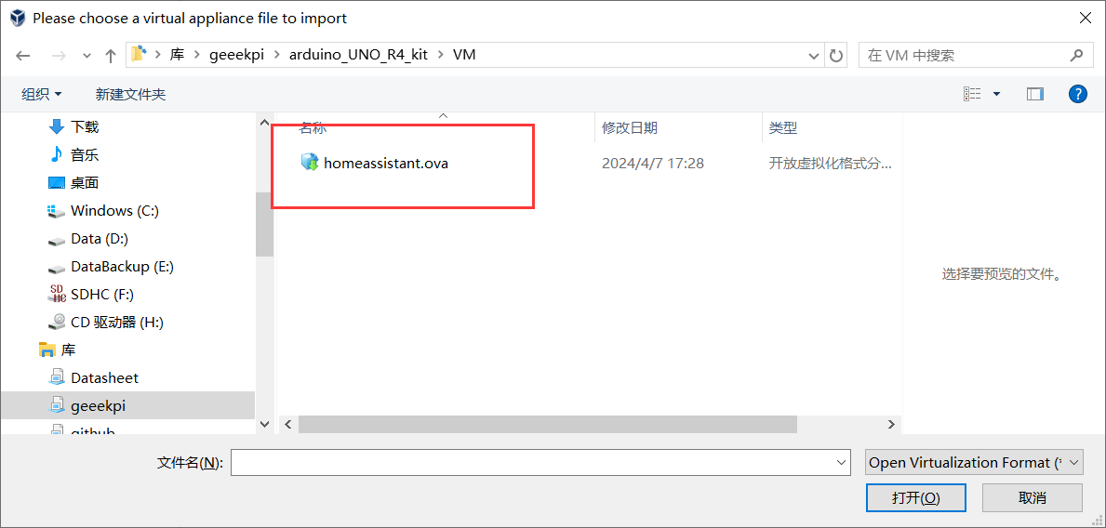

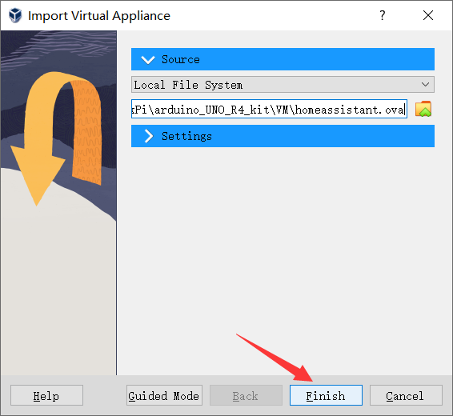

waiting for a while:
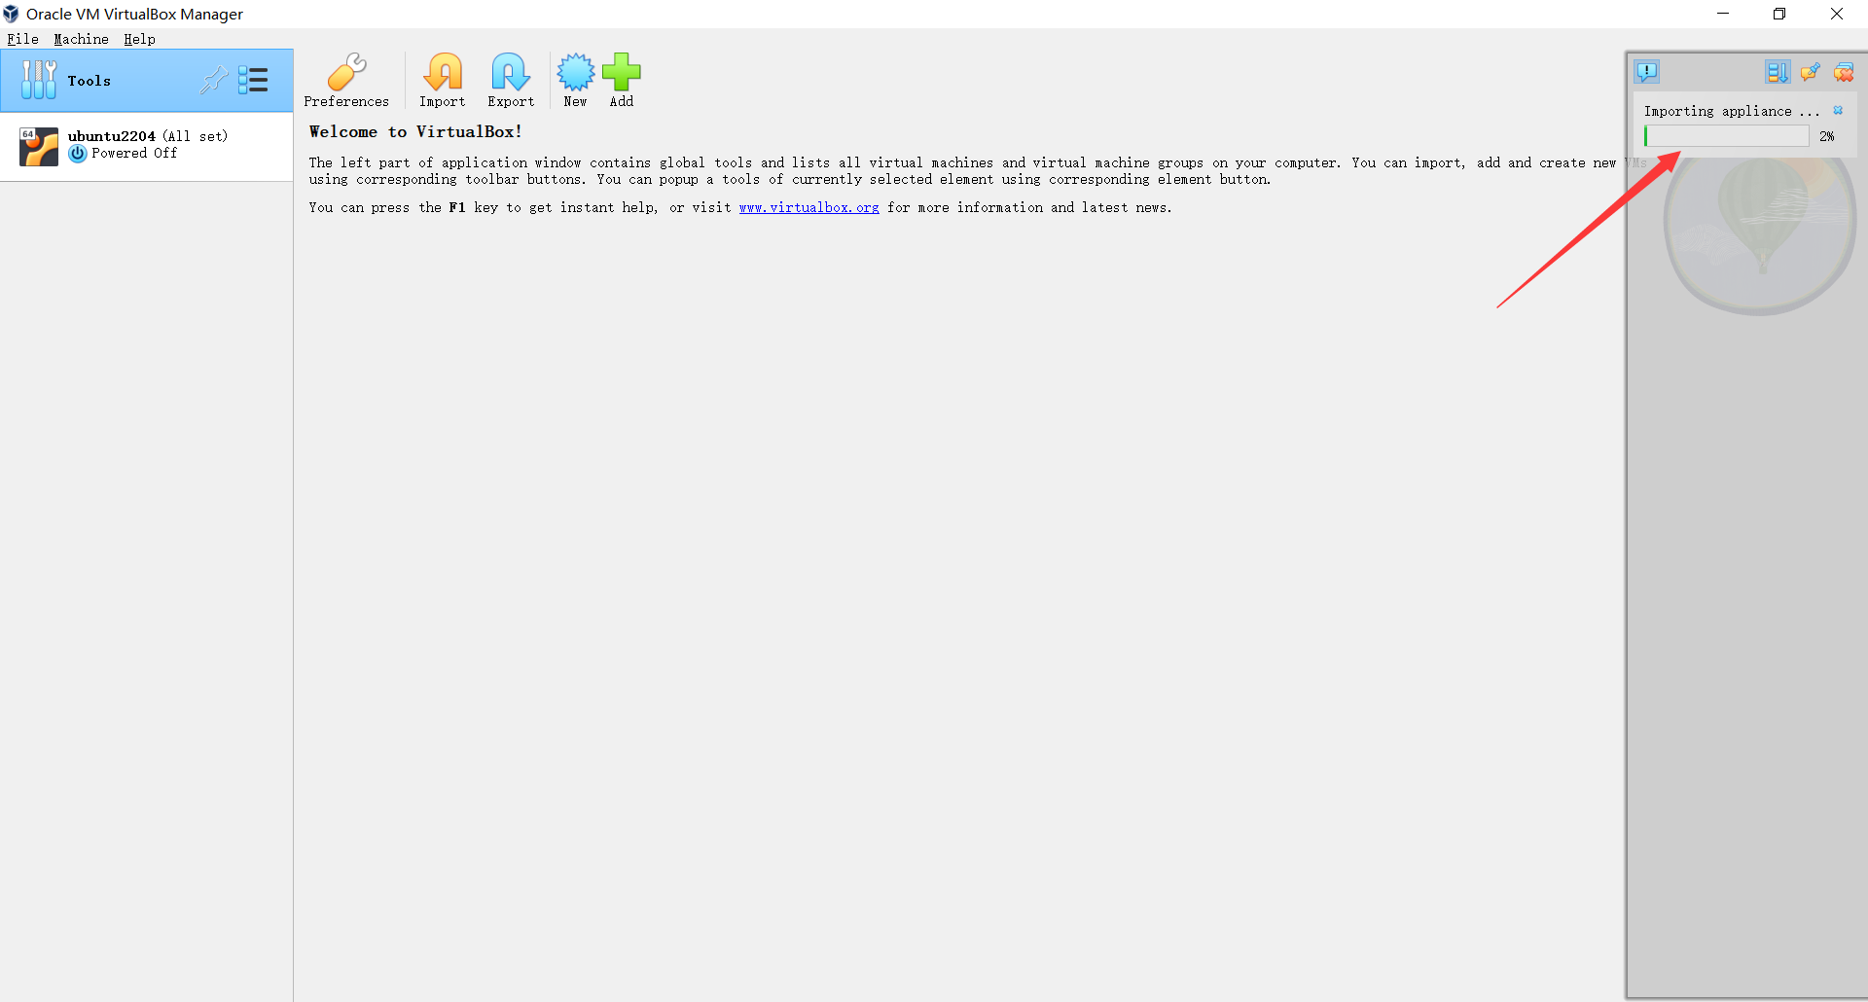

Turn on virtual machine
Navigate to the vm folder in TF card, and then double click “homeassistant” file.
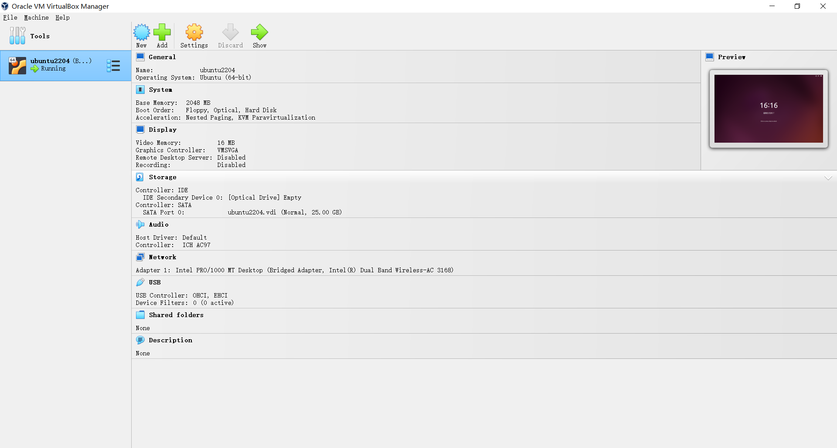
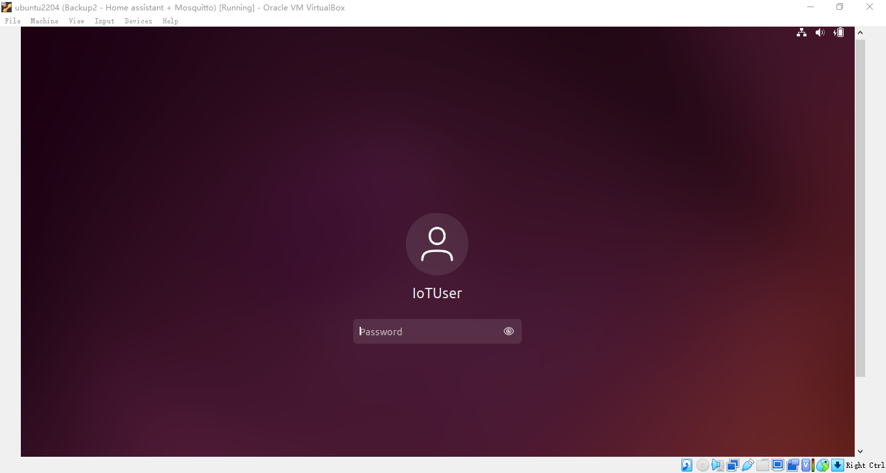
User name: IoTUser
Password: iotuser

Open a terminal and check the IP Address:
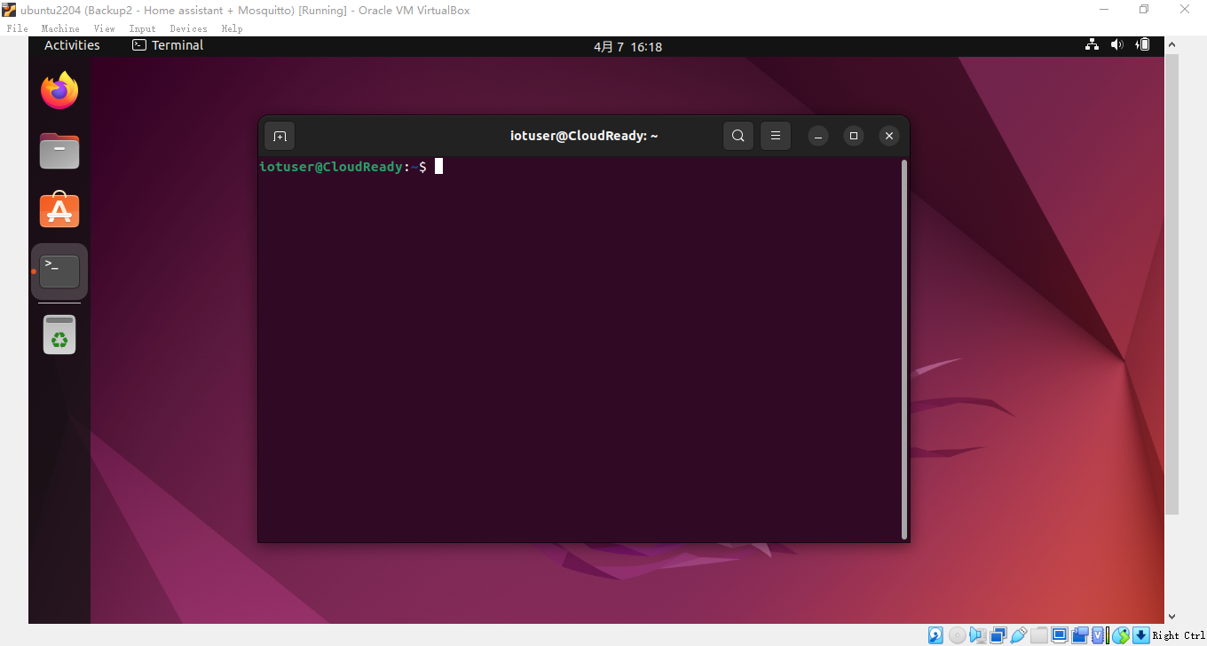
Command: ip addr
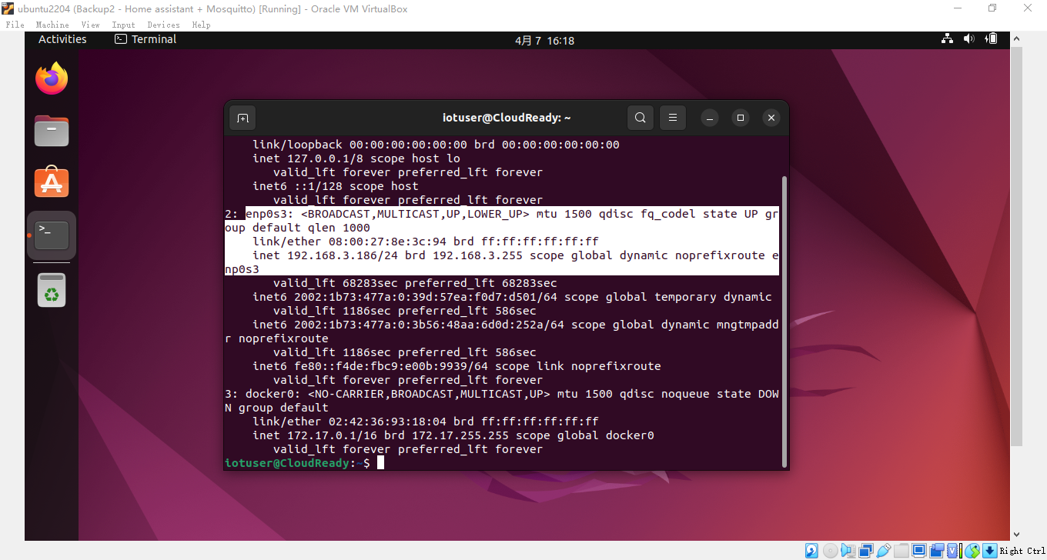

Restart Docker services
Open a terminal and typing:
sudo docker restart $(sudo docker ps -a -q)
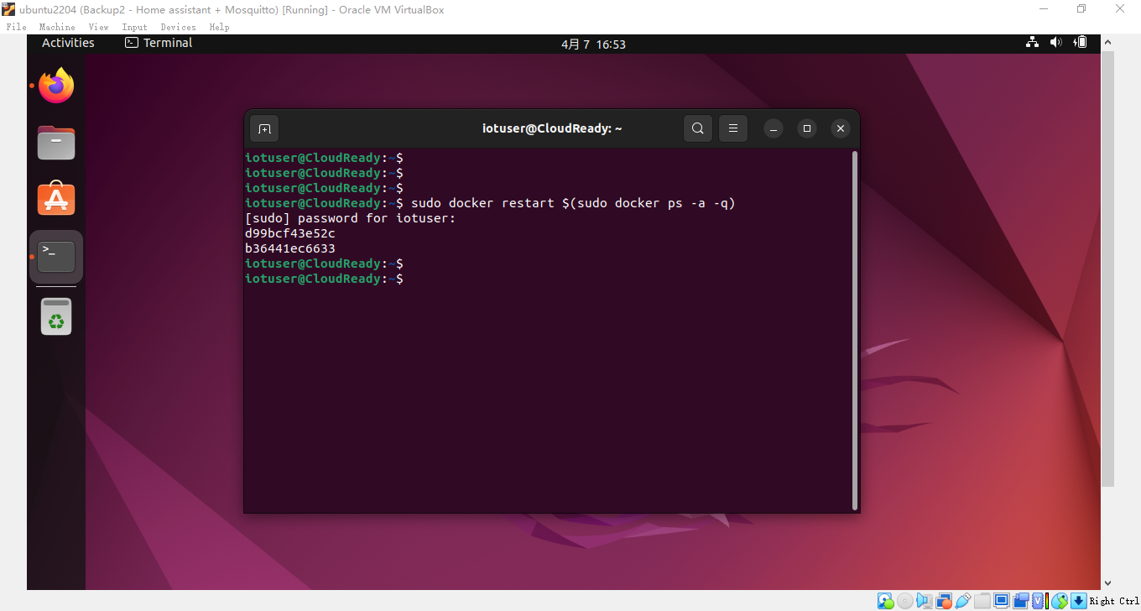
Open a browser and typing IP address and port to access home assistant system
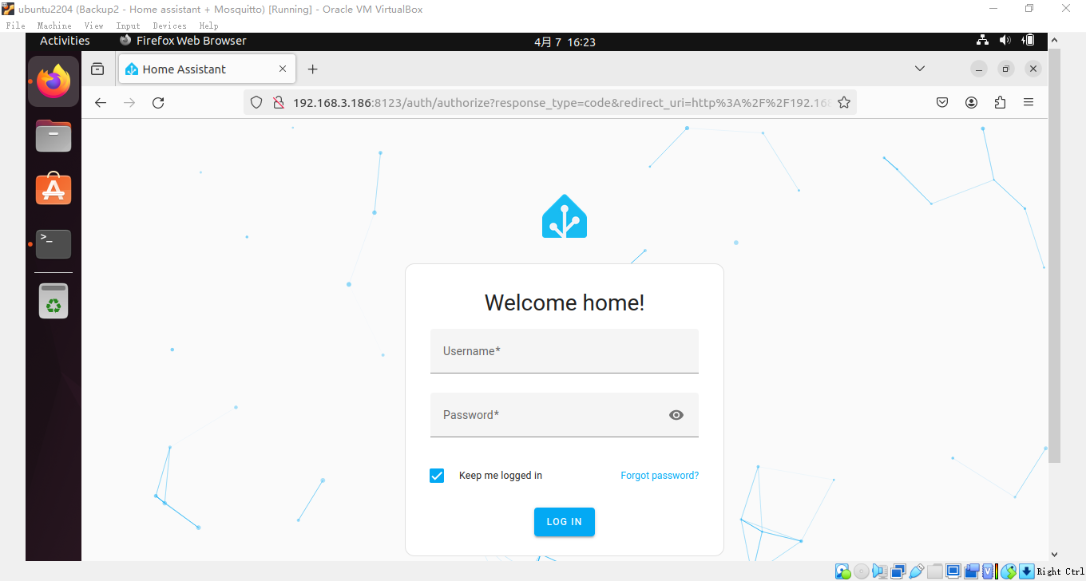
User Name: admin
Password: admin
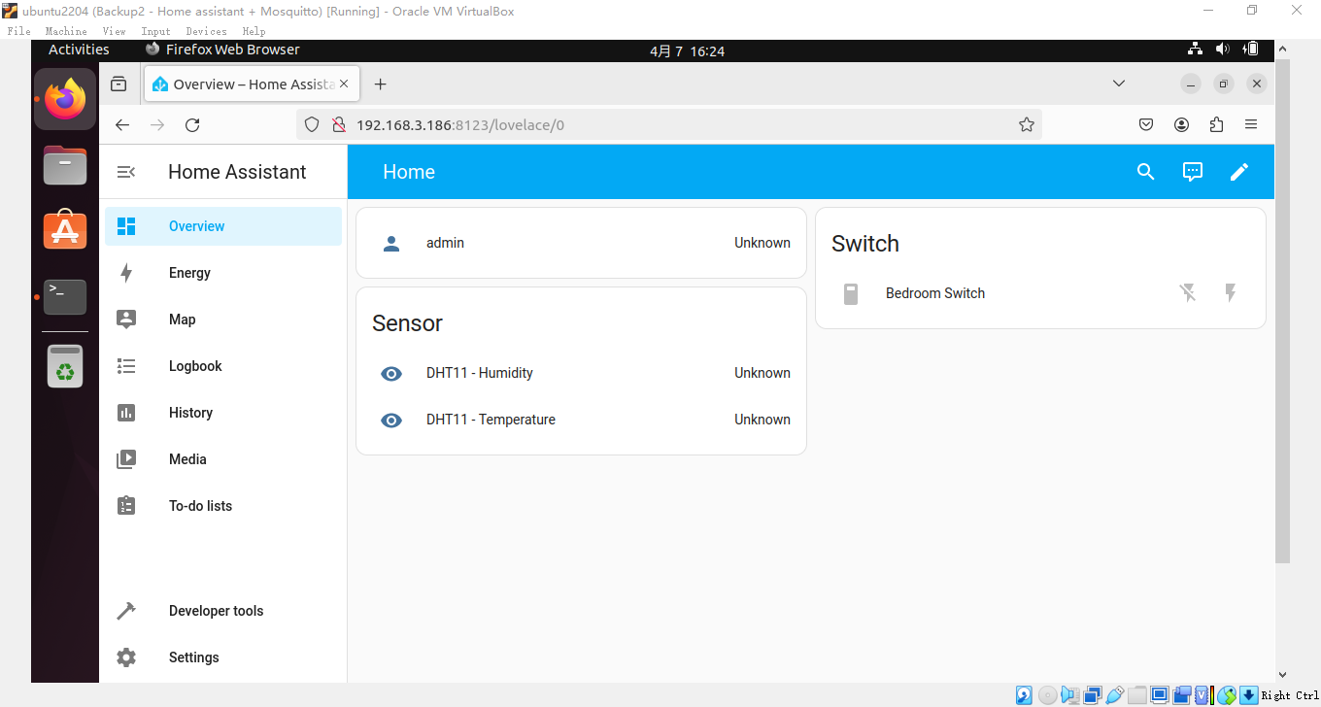

Have fun!
Note: You can modify the configuration.yaml file in location :
/opt/homeassistant/configure.yaml

Do remember restart home assistant after modifying the configuration file.

